**Tableau- Assignment 5**

1. Using the PowerStore_USA dataset, create a visualization that displays two measures “Sales” and “Profit” side by side using “Side by Side Bars”. Use the dimension YEAR (Order Date) represented as discrete values for the above problem.

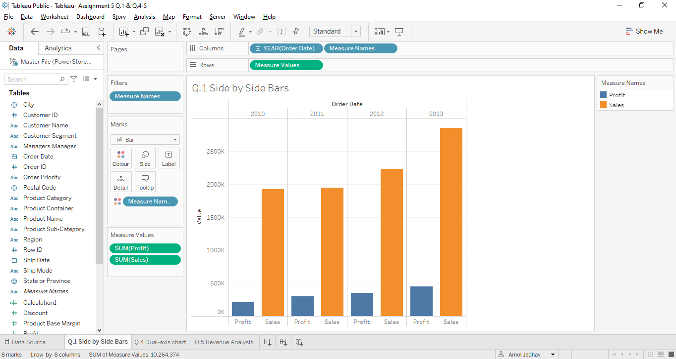

1. Using the Global Superstore Orders 2016 dataset, create a visualization wherein multiple measures are plotted on the same axis. You may depict at least 3 measures of your choice in your visualization e.g. Sales, Profit, Discount etc.

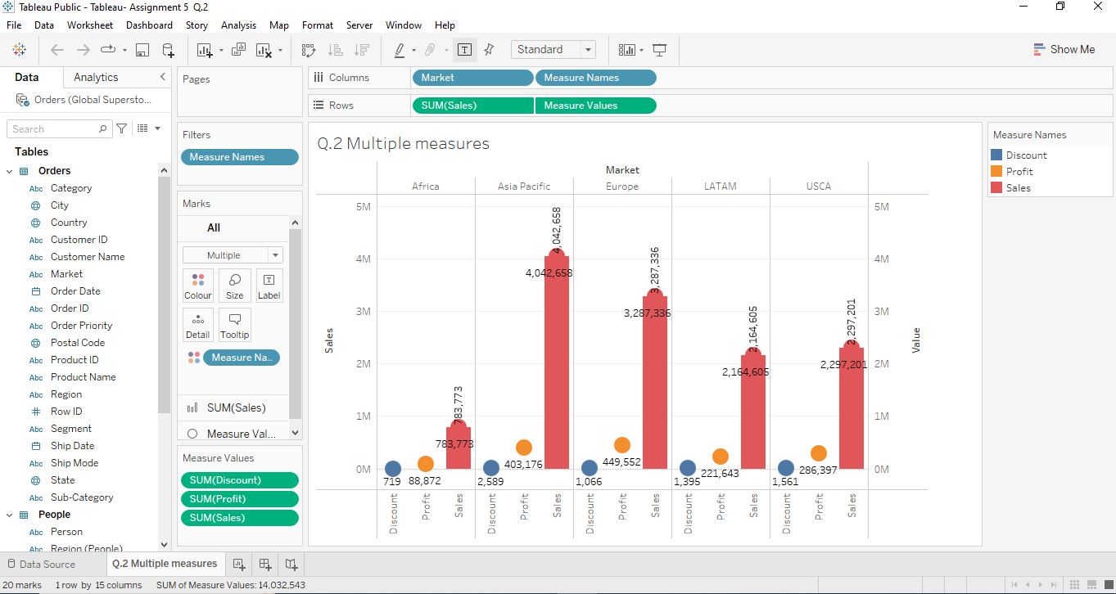

1. Consider the situation as described: you have been sitting for the UPSC exams for the past four years. Now in order to improve your performance in your last attempt, you wish to analyze your performance in each subject over the course of four years. Draw a graph to show how well you performed in each topic throughout the course of your four previous attempts so that you can clearly see which subject you need to improve on. Plot a slope graph showcasing the first and fourth years' results. You are required to create a dummy data wrt to the above context, you can keep the data as short or as large as you may.

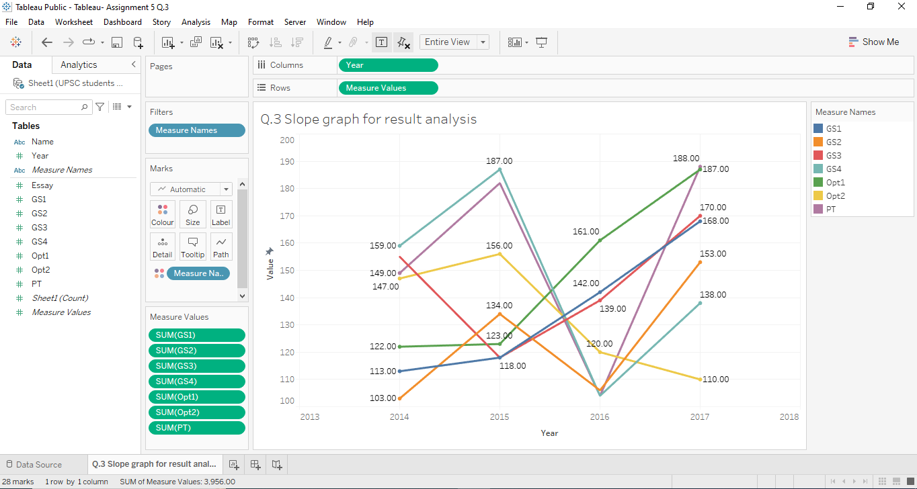

1. You want to improve your company's marketing plans for its goods and services as a top executive. When developing creative marketing tactics, having a solid understanding of how profit performs as sales increase year over year will serve you well. Plot a "Sales" and "Profits" dual-axis chart so that you can understand the trends in both these measures over the years in the same view. Use the dimension YEAR(Order Date) represented as discrete values for the above problem.

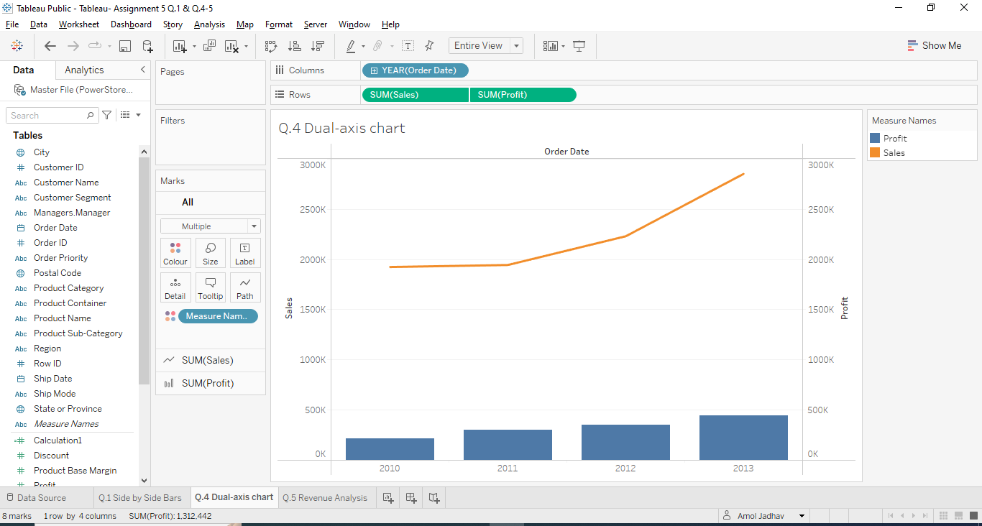

1. The retail establishment "Gmart" offers a wide variety of products under many headings, including “Mobile Devices," "Home Appliances," "Home Decor," "Stationary," and "Apparels," among others. You are a senior business analyst and would like to discover which subcategories make up the top half of the total revenue. Make a visualization that will aid your comprehension. You can either use a self-created dataset with no restrictions on the number of rows and columns or you can also go for the datasets provided by us. You may even use sub-categories of your own choice.

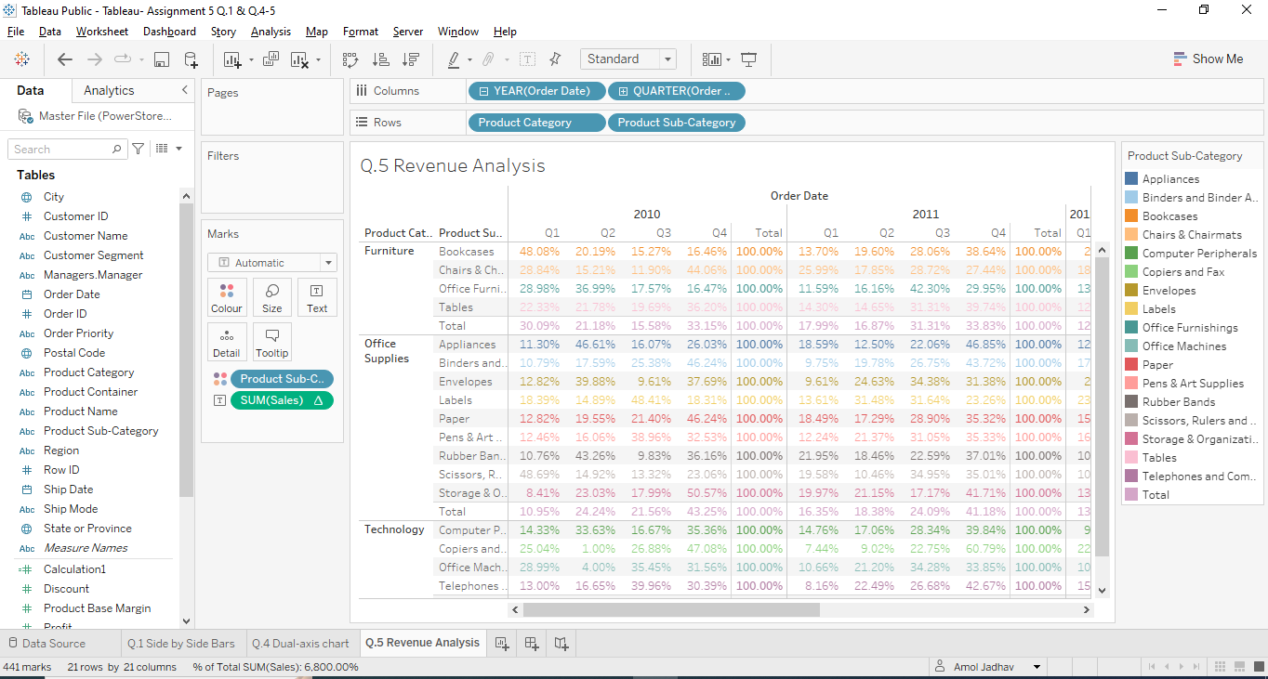

[*PFA links for the datasets used.*](https://drive.google.com/drive/folders/123UyMRbrReCjyn1K4g_FhsjKx6cP4zLH?usp=sharing)